**INTRODUCTION TO ARTIFICIAL INTELLIGENCE (AI)**

* **ARTIFICIAL INTELLIGENCE (AI)**

 

Have you used snapchat filters or talked to Alexa, how do they do it?

Snapchat filters always align to your face and Alexa replying to you properly and as per your request? Magic, isn’t it? Well it’s all due to Artificial Intelligence.

Artificial Intelligence (AI) is the machine-displayed intelligence that simulates human behaviour or thinking and can be trained to solve specific problems. The softwares are pre trained with data have the ability to make intelligent decisions and respond to requests made as per you.

## **WHAT IS ARTIFICIAL INTELLIGENCE?**



Let’s us understand the meaning of artificial intelligence, let us break down the words first. Artificial means not man made and intelligence means using the cognitive skills which were pre taught to the program using a set of data.

Eg- WALL-E from the movie WALL-E who uses his own cognitive skills to do tasks and save other robots.

## **DECISION MAKING IN ARTIFICIAL INTELLIGENCE**

Humans may not be totally reliable or consistent in decision making, but they still bring important competencies to the table. Similarly, AI in decision making has its place.

Decision automation, decision augmentation and decision support represent the degrees to which AI and analytics are used to get faster, more consistent, more adaptable and higher-quality decisions at a particular time.

The differences lie in the analytics techniques used at various points in the decision process, and who (or what) ultimately makes the decision:

1. **Decision automation**

The system makes the decision using prescriptive analytics or predictive analytics. Its benefits include speed, scalability and consistency of decision making. Hence all the work is done by the system all the calculations and we have given it complete control over the decision making. Eg- This machine uses all the possibilities and it’s skills to to take a decision and play chess to win it.

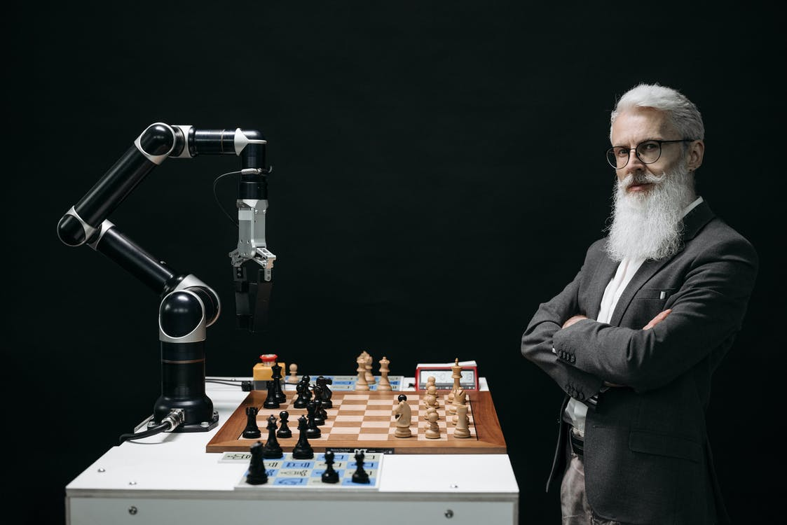

**2. Decision augmentation**

 The system recommends a decision, or multiple decision alternatives, to human actors using prescriptive or predictive analytics. Its benefits lie in the synergy between human knowledge and the capability of AI to rapidly analyse high volumes of data and to deal with complexity. Eg – Whenever this rover comes across something on Mars it gives the calculations and possibilities to his command post which then takes a decision.

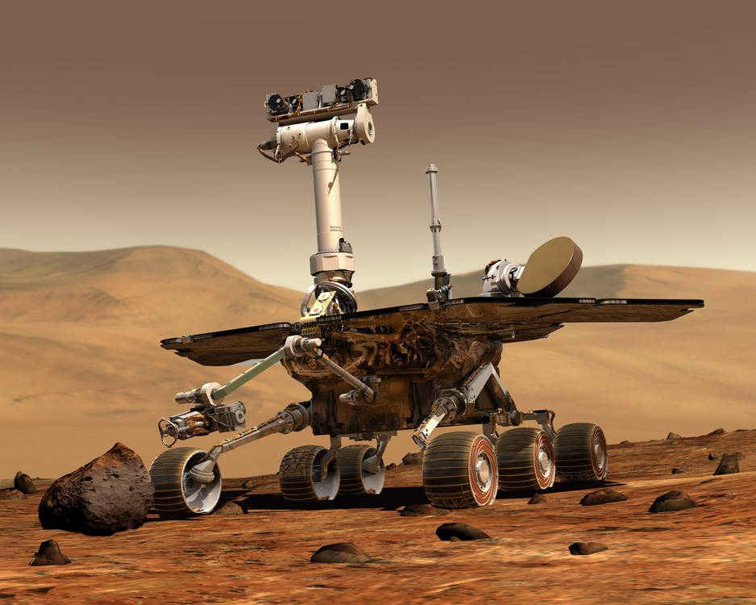

**3. Decision support**

Human employees make the decision, supported by descriptive, diagnostic or predictive analytics. Its main benefit lies in the combined application of data-driven insights and human knowledge, expertise and common sense, including “gut feel” and emotions. Eg – The GPS in our cars uses the analytics to give us a faster route out, but we drive the car according to our route and take help/support from the GPS

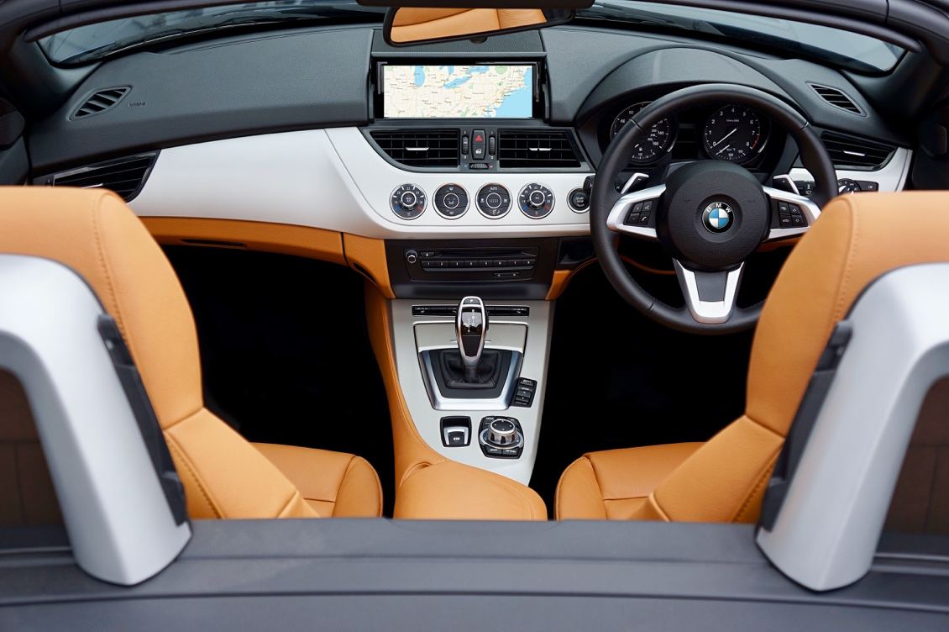

**TASK -** <https://funzone.funoppia.com/maze.html>

**Complete the Chase the Maze game in Funzone**

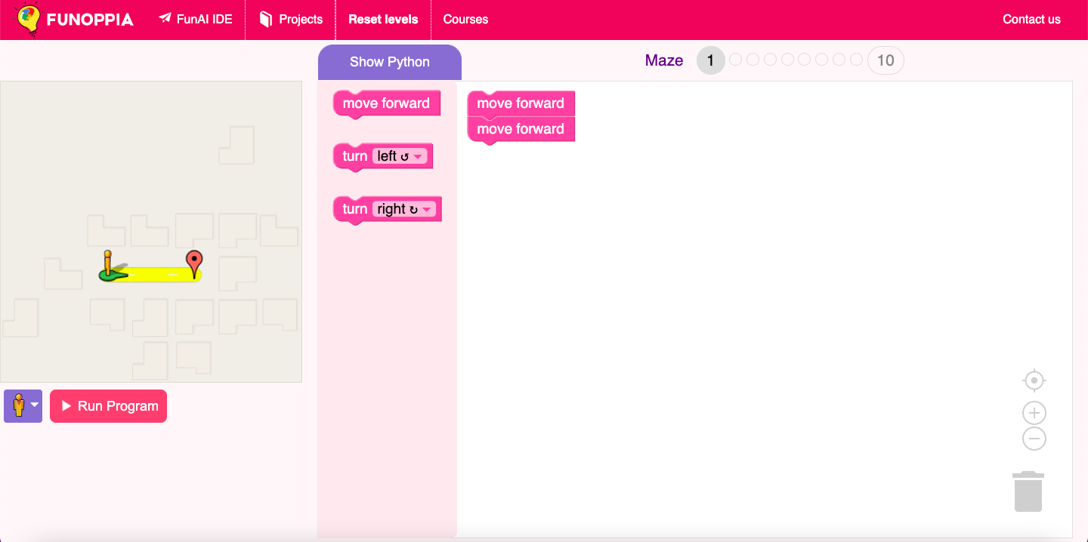

## **WHAT IS AI AND WHAT IS NOT AI?**

So you must be wondering how do we differentiate between whether a machine is AI or not? It is very simple, you just need to keep in mind whether the machine/robot uses their cognitive skills to complete the given task or not. Cognitive skills means the ability to use one’s own thinking capabilities/skills. Eg – A tesla car when in autopilot is an example of AI but when the autopilot is switched off or it is a non AI car and is controlled by a person, the car does what it is simply directed to like turn or brake. The car would not use anything if a person is driving and drives it into another car the carwould not stop itself unless brake is pushed. Otherwise if it would have been a Tesla in autopilot it would have stopped before hitting another car. On the left is a Tesla in autopilot mode.



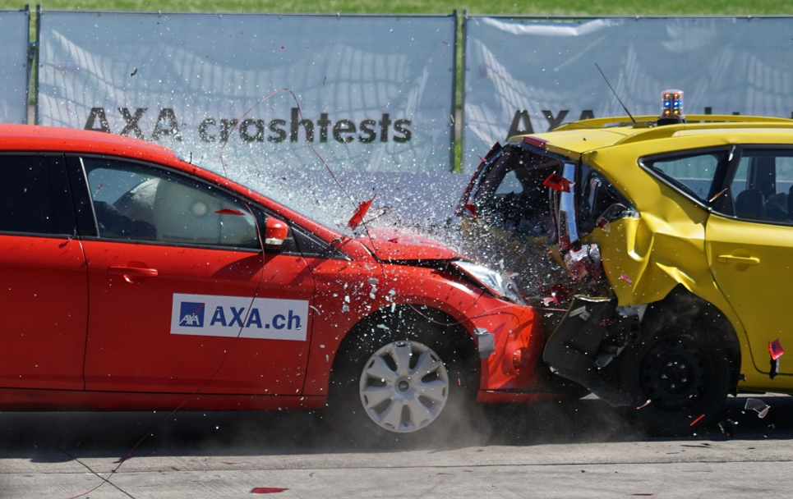

* **AI VS ML VS DL**

|  |  |  |
| --- | --- | --- |
| **ARTIFICIAL INTELLIGENCE** | **MACHINE LEARNING** | **DEEP LEARNING** |
| Is a science like mathematics or biology. It studies ways to build intelligent programs and machines that can creatively solve problems, which has always been considered a human prerogative. | is a subset of artificial intelligence (AI) that provides systems the ability to automatically learn and improve from experience without being explicitly programmed. In ML, there are different algorithms (e.g. neural networks) that help to solve problems | is a subset of machine learning, which uses the neural networks to analyse different factors with a structure that is similar to the human neural system. |
| It is the overview of the others and others are consisted within Artificial Learning | It is a subset of Artificial Learning | It is a subset of Machine Learning |
| Eg – Jarvis and Friday, Ultron from Avengers and Vision, The robot used in hospitals etc.  High-Angle Photo of Robot | Eg – A machine which uses a camera to identify whether the animal is a cat or dog.    DOG    CAT | Eg – Creating a star using Funoppia IDE |

MACHINE

LEARNING

DEEP

LEARNING

ARTIFICIAL INTELLIGENCE

* **DOMAINS OF AI**

The main Branches of Artificial Intelligence for eg : Data Science, Computer Vision and Natural Language Processing. Further it is divided into tasks.

FORMAL

TASKS

MUNDANE

TASKS

ARTIFICIAL

INTELLEGENCE

EXPERT

TASKS

|  |  |  |
| --- | --- | --- |
| **MUNDANE TASKS** | **FORMAL TASKS** | **EXPERT TASKS** |
| Perception   * Computer Vision * Speech, voice | Games   * Chess * Checkers | Engineering   * Design * Fault finding |
| Natural Language Processing   * Understanding * Language generation/translation | Mathematics   * Geometry * Logic | Scientific Analysis |
| Eg – Creating a face recognition software. | Eg – Creating tic tac toe game. | Eg – Creating designs using the turtle module. |

**TASK –** [**https://funzone.funoppia.com/turtle.html**](https://funzone.funoppia.com/turtle.html)

**Complete the Canvas game in Funzone**

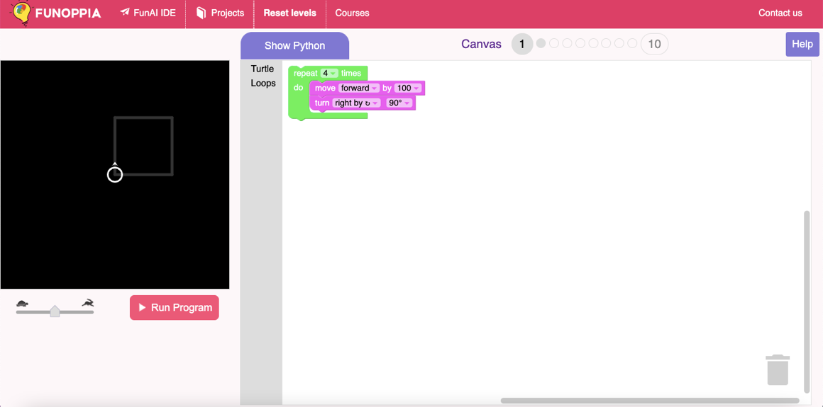

* **APPLICATIONS OF AI**

Artificial Intelligence has various applications in today's society. It is becoming essential for today's time because it can solve complex problems with an efficient way in multiple industries, such as Healthcare, entertainment, finance, education, etc. AI is making our daily life more comfortable and fast.

Examples –

1. Gaming

AI can be used for gaming purpose. The AI machines can play games where the characters use their inbuilt set to kill you in a game and use their own techniques. Or in racing games like NFS.

1. Astronomy

Artificial Intelligence can be very useful to solve complex universe problems. AI technology can be helpful for understanding the universe such as how it works, origin, etc.



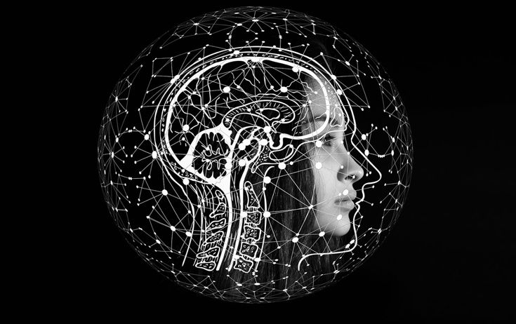

3. Robotics

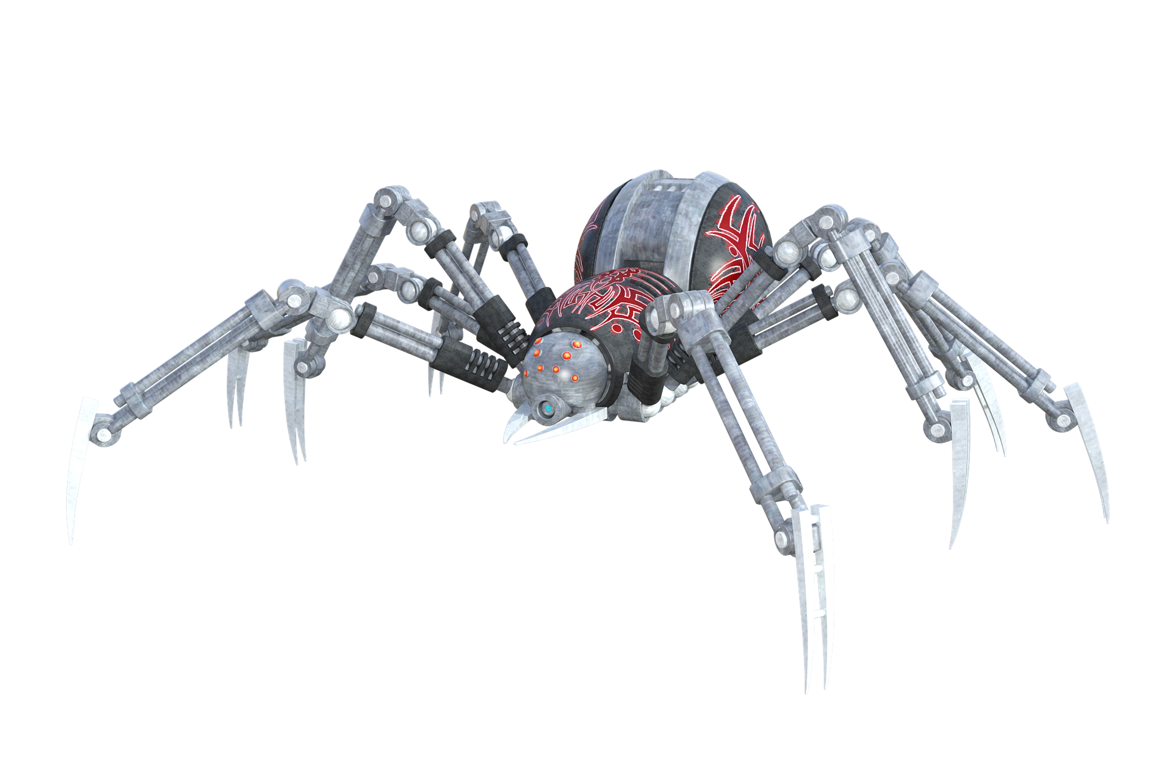

Artificial Intelligence has a remarkable

role in Robotics. Usually, general

robots are programmed such that they

can perform some repetitive task, but

with the help of AI, we can create

Intelligent robots which can perform

tasks with their own experiences

without pre-programmed. Like this spider robot was in Transformers movie aswell, where the decepticons were evil and used the AI technology for harm.

4. Face Mask Recognition Software –

This project checks whether the person using it is wearing a mask or not, go try and check it out on - <https://projects.funoppia.com/mask/>

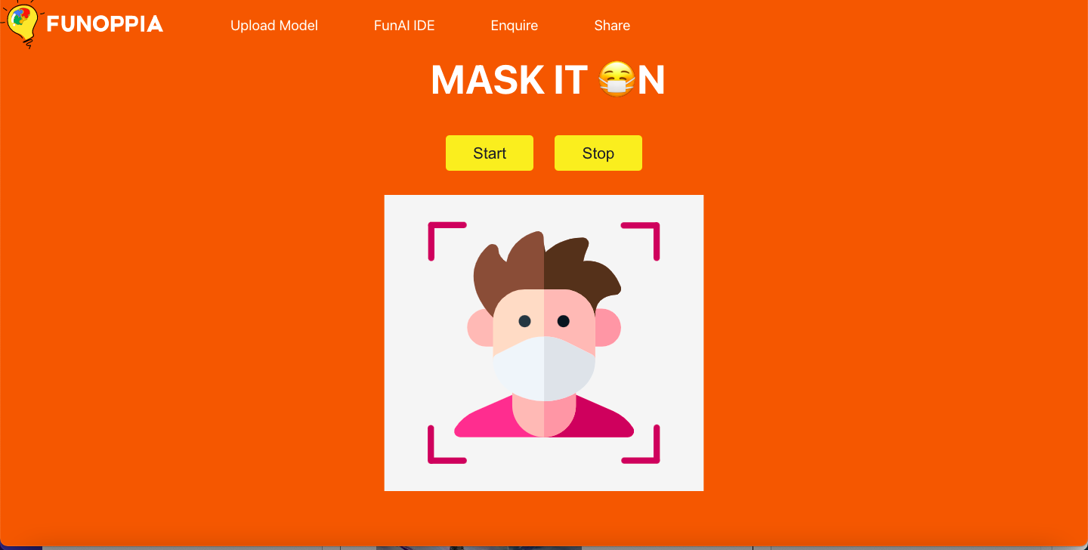

5. Make a Face (Filters) -

This is a project which puts filters on your face to try on. Try the project on -<https://projects.funoppia.com/filter/>

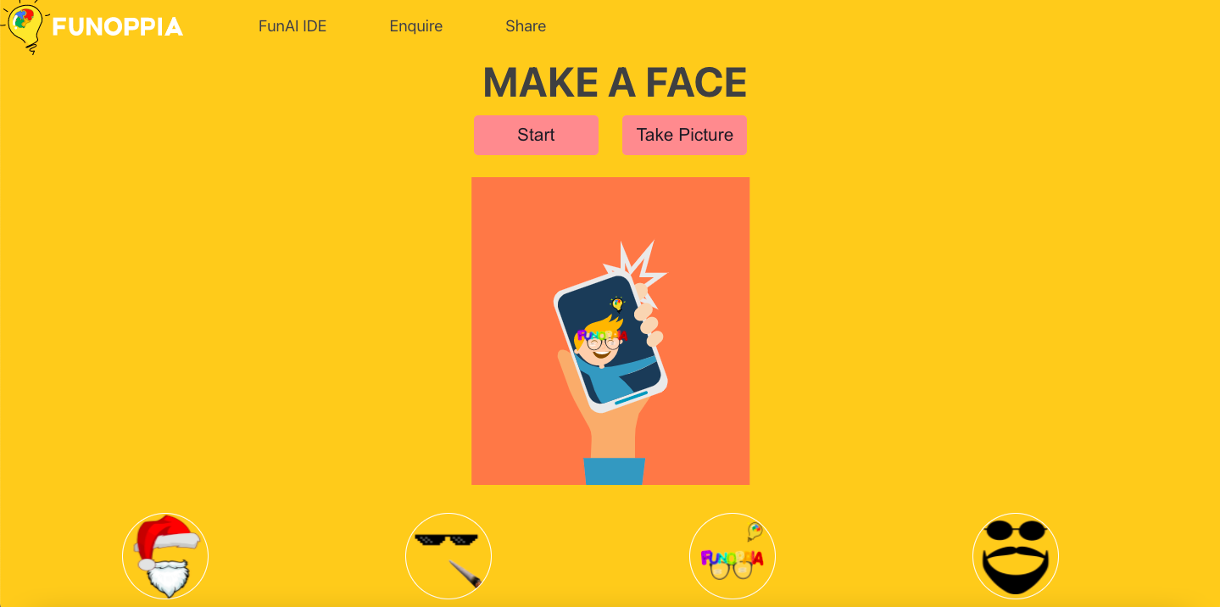

* **AI ETHICS**

Artificial Intelligence ethics, or AI ethics, comprise a set of values, principles, and techniques which employ widely accepted standards of right and wrong to guide moral conduct in the development and deployment of Artificial Intelligence technologies.

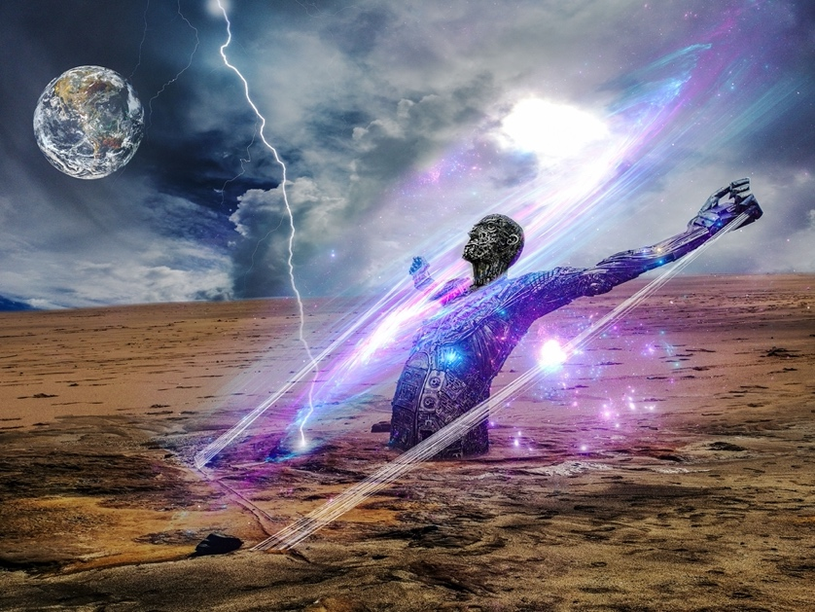

Eg- you cannot create an intelligence system that differentiates and treats different people or genders differently. As in the movie RaOne they had 2 different artificial intelligences namely RaOne and GOne, RaOne was the bad intelligence which wanted to hurt the human kind.



Another example is from the movie Transformers where bumblebee and optimus prime are the good transformers who want to save the Earth that is why they were supported by the US Military aswell to save the world from the Decepticons.

Hence to embed these qualities in the AI is extremely important and necessary to prevent unnecessary problems in the future.



**PRACTICE QUESTIONS**

Q1. Which of the following can be called as Artificial Intelligence?

1. Siri
2. Google Assistant
3. Spotlight Search
4. Chrome

Q2. Differentiate as Decision Automation, Decision Augmentation and Decision Support.

1. Your mom asked you to go to the market and bring a pack of chips of your choice.
2. Your computer asks you to shut down or restart.
3. Tony says Jarvis to make him a cup of coffee.
4. Your father asks you to help him pick a car which he wants to buy.
5. You are riding a cycle and a stone is in your way.

Q3. Differentiate as AI or not AI.

1. Siri.
2. Machine that packs chips.
3. Mobiles.
4. A smart watch.
5. Tesla Autopilot.

Q4. Can Humanoid Robots be termed in as Artificial Intelligence?

1. True
2. False

Q5. Give 3 more examples where Artificial intelligence is used.

Q6. Give an example of your choice for AI Project Cycle.

**PRACTICE HOTS QUESTIONS**

Q1. A robot has gone rogue (out of control) and is out in the streets, does this go against the AI Ethics? Explain.

Q2. A person is driving a Tesla and enables autopilot, as soon as he takes out his seatbelt the car stops immediately. Which type of decision is this?

Q3. Your mom asked you to go the market using the main road, but there is a puddle of water there, you take another route. Which type of decision is this?